

IRF25/790

Gateway determination report – PP-2025-604
Woollahra Dwelling Retention Policy
September 25

Published by NSW Department of Planning, Housing and Infrastructure
dpie.nsw.gov.au
Title: Gateway determination report – PP-2025-604
Subtitle: Woollahra Dwelling Retention Policy
© State of New South Wales through Department of Planning, Housing and Infrastructure 2025. You may copy, distribute, display, download and otherwise freely deal with this publication for any purpose, provided that you attribute the Department of Planning, Housing and Infrastructure as the owner. However, you must obtain permission if you wish to charge others for access to the publication (other than at cost); include the publication in advertising or a product for sale; modify the publication; or republish the publication on a website. You may freely link to the publication on a departmental website.
Disclaimer: The information contained in this publication is based on knowledge and understanding at the time of writing (September 25) and may not be accurate, current or complete. The State of New South Wales (including the NSW Department of Planning, Housing and Infrastructure), the author and the publisher take no responsibility, and will accept no liability, for the accuracy, currency, reliability or correctness of any information included in the document (including material provided by third parties). Readers should make their own inquiries and rely on their own advice when making decisions related to material contained in this publication.

Acknowledgment of Country
The Department of Planning, Housing and Infrastructure acknowledges the Traditional Owners and Custodians of the land on which we live and work and pays respect to Elders past, present and future.

Contents
1 Planning proposal 1
1.1 Overview 1
1.2 Objectives of planning proposal 1
1.3 Explanation of provisions 1
1.4 Site description and surrounding area 2
1.5 Mapping 3
1.6 Background 3
2 Need for the planning proposal 3
3 Strategic assessment 3
3.1 Regional Plan 3
3.2 District Plan 4
3.3 Local 4
3.4 Local planning panel (LPP) recommendation 5
3.5 Section 9.1 Ministerial Directions 5
3.6 State environmental planning policies (SEPPs) 7
State Environmental Planning Policy (Housing) 2021 7
4 Site-specific assessment 8
4.1 Environmental 8
4.2 Social and economic 8
4.3 Infrastructure 9
5 Consultation 9
5.1 Community 9
5.2 Agencies 9
6 Timeframe 9
7 Local plan-making authority 10
8 Assessment summary 10
9 Recommendation 10

Planning proposal

Overview
Table 1 Planning proposal details
LGA | Woollahra
PPA | Woollahra Municipal Council
NAME | Woollahra Dwelling Retention Policy
NUMBER | PP-2025-604
LEP TO BE AMENDED | Woollahra Local Environmental Plan 2014
ADDRESS | Whole of LGA
DESCRIPTION | Policy Amendment
RECEIVED | 31/03/2025
FILE NO. | IRF25/790
POLITICAL DONATIONS | There are no donations or gifts to disclose and a political donation disclosure is not required
LOBBYIST CODE OF CONDUCT | There have been no meetings or communications with registered lobbyists with respect to this proposal

Objectives of planning proposal
The planning proposal contains objectives and intended outcomes that adequately explain the intent of the proposal.
The objectives of the planning proposal are to:
- Reasonably minimise the net loss of housing stock in the Woollahra LGA;
- Support housing diversity and affordability;
- Maintain and grow housing supply in the Woollahra LGA; and
- Retain residential dwelling density and diverse housing choice.
The objectives of this planning proposal are clear and adequate.

Explanation of provisions
The planning proposal seeks to amend Part 6 of the Woollahra LEP 2014 to introduce a new local provision relating to dwelling retention. The new provision will:
- Apply to development approvals and/or modifications that seek to redevelop residential accommodation where three or more dwellings are contained within the whole development site, with exceptions for boarding houses, co-living housing, group homes, secondary dwellings, and residential care facilities, or where dwelling loss is the result of conversion to non-residential land uses.
- Restrict dwelling loss so that any net reduction in dwellings is no more than 15% of dwellings (rounded to the nearest whole number), or 1 dwelling, whichever is greater.
- Define the baseline number of dwellings of a specific site, as the number of dwellings onsite, at the time at which the clause is enacted and prohibit successive development applications that reduce the baseline number of dwellings onsite by 15% (rounded to the nearest whole number) or by 1, whichever is greater.
The planning proposal also seeks to amend clause 1.8A of the LEP to include a savings provision so that the amendments will only apply to applications submitted after the date that the planning proposal is finalised.
The planning proposal contains an explanation of provisions that adequately explains how the objectives of the proposal will be achieved.

Site description and surrounding area
The planning proposal applies to land within the Woollahra LGA as shown in Figure 1.
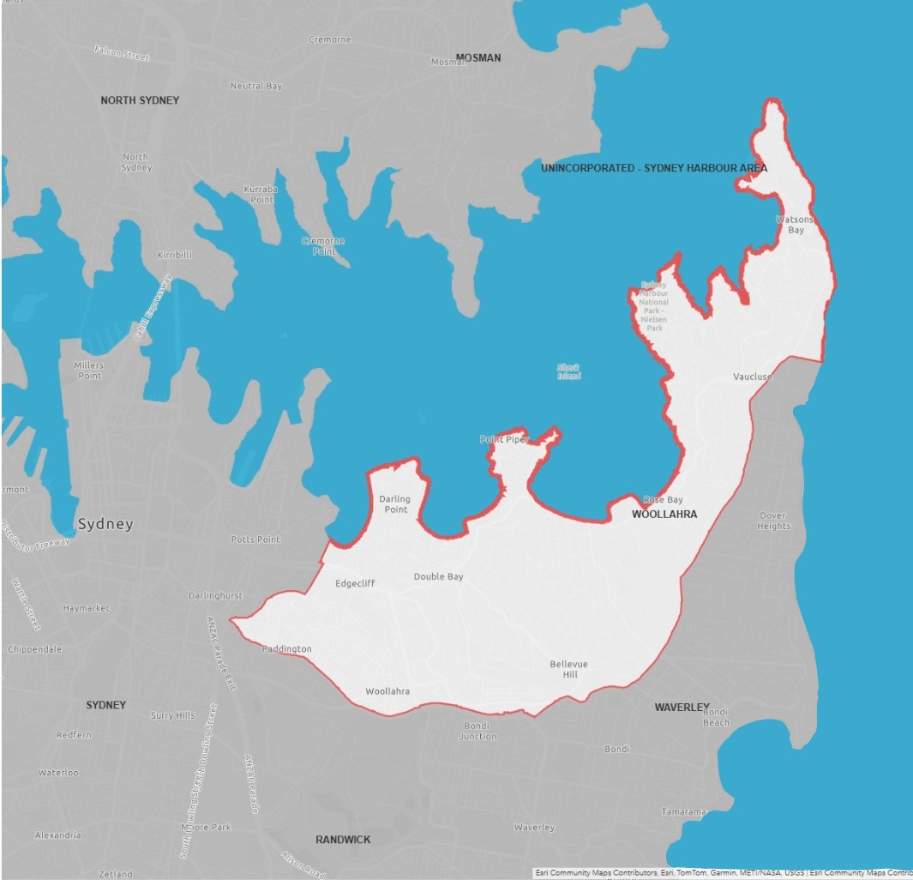
Figure 1 Woollahra Local Government Area (Source: OLG)

Mapping
No mapping amendments are proposed as part of this planning proposal.

Background
On 28 August 2023, Woollahra Council raised concerns of dwelling loss across the LGA and passed a motion that Council staff urgently investigate and report on opportunities to prepare a planning proposal to include objectives and controls in the Woollahra Local Environmental Plan 2014 to prevent the net reduction of dwellings on development sites.
On 24 March 2025, Woollahra Council resolved to endorse the Woollahra Dwelling Retention Planning Proposal and refer the proposal to the NSW Department of Planning, Housing and Infrastructure for gateway assessment. The report to Council in support of the Planning Proposal identified 42 development applications between 2020 and 2025 which either resulted in or are proposing dwelling loss.
Council submitted the planning proposal (PP-2025-604) to the Department for Gateway assessment on 31 March 2025. The Department has recently finalised a similar dwelling retention proposal with the City of Sydney Council, while Waverley Council discontinued their proposal to facilitate a like outcome.

Need for the planning proposal
Q1. Is the planning proposal a result of an assured local strategic planning statement, or Department approved local housing strategy, employment strategy or strategic study or report?
No. The planning proposal is not the result of a Department approved study or report, however it is the result of investigations conducted by Woollahra Municipal Council which analysed dwelling loss across the LGA. The study found 42 DAs between March 2020 and January 2025, that have resulted in or are proposing a net dwelling loss. The total number of dwellings lost as a result of these applications is 93. Council have identified concern that this dwelling loss is impacting its ability to meet the NSW Government dwelling target for Woollahra Council and is reducing dwelling diversity in the LGA.
Q2. Is the planning proposal the best means of achieving the objectives or intended outcomes, or is there a better way?
Yes. The objective of the proposal is to provide a statutory mechanism to minimise the net loss of housing stock in the Woollahra LGA. The intended outcomes of the proposal cannot be delivered under the current planning framework and a planning proposal is required to amend the Woollahra LEP 2014.
While the planning proposal includes adequate justification for the need to address the trend of loss of diverse and affordable housing choices, adequate justification has not been provided to demonstrate that the proposed numerical standard is the most appropriate standard. Justification to support the proposed provision that a net reduction in dwellings is no more than 15% of dwellings (rounded to the nearest whole number), or 1 dwelling, whichever is greater, relies on analysis conducted by the City of Sydney and Waverley for their respective proposals.
It is acknowledged that this proposal is comparable to the dwelling retention amendments which have been proposed by the City of Sydney and Waverley. However, the social and economic implications of this proposal must be assessed within the context of the Woollahra LGA. It is also noted that Waverley Council have not progressed their proposal to finalisation.
A condition has been included in the Gateway determination requiring that the planning proposal is updated prior to community consultation to provide greater explanation and justification as to why the 15% or 1 dwelling, whichever is greater, numerical standard has been selected. This is to include scenario analysis of recent development sites, with and without proposed dwelling retention provisions, under current planning controls. The scenario analysis should measure dwelling loss and resulting average dwelling size in sqm. The final planning proposal document for City of Sydney dwelling retention planning proposal includes analysis of this nature.
A condition has also been included to update the planning proposal explain how the proposed provision will apply to zones predominately characterised by employment or mixed uses. This condition was also applied to the City of Sydney dwelling retention planning proposal.
The City of Sydney dwelling retention planning proposal (PP-2024-27) has been finalised and came into effect 30 May 2025.

Strategic assessment

Regional Plan
The Greater Sydney Region Plan – A Metropolis of Three Cities (March 2018) (the Plan) was prepared by the former Greater Sydney Commission. Key objectives of the Region Plan are Infrastructure and Collaboration, Liveability, Productivity and Sustainability.
The proposal is generally consistent with the Plan. A more detailed evaluation of its consistency is provided in the assessment of the Eastern City District Plan below, which is strategically aligned with the Region Plan, giving it effect.

District Plan
The site is within the Eastern Harbour City District and the former Greater Sydney Commission released the Eastern Harbour City District Plan on 18 March 2018. The district plan contains planning priorities and actions to guide the growth of the district while improving its social, economic and environmental assets.
The Department is satisfied the planning proposal gives effect to the District Plan in accordance with section 3.8 of the Environmental Planning and Assessment Act 1979 (EP&A Act). Table 2 assesses the planning proposal against the relevant priorities and actions of the District Plan.
Table 2 District Plan assessment
District Plan Priorities | Justification
Planning Priority E5  Providing housing supply, choice and affordability, with access to jobs, services and public transport | The planning proposal is consistent with this priority as it aims to minimise the dwelling loss which has occurred as a result of recent trends within the LGA, whereby residential flat buildings are being redeveloped and consolidated into a lower number of larger high-end dwellings.  The priority includes housing targets for the LGA’s within the Eastern Harbour City, including Woollahra, these targets were subsequently updated by the NSW Government in 2024. The planning proposal will limit reductions in housing supply and diversity.

Local
The proposal states that it is consistent with the following local plans and endorsed strategies, including strategic directions and objectives, as stated in the table below.
Table 3 Local strategic planning assessment
Local Strategies | Justification
Woollahra Local Strategic Planning Statement 2020 (WLSPS) | Priority 4 of the WLSPS aims to sustain a diverse range of housing choices across the Woollahra LGA.  The planning proposal seeks to limit developments that are resulting in a net dwelling loss and reducing the level of housing stock within the Woollahra LGA. Additionally, the planning proposal will assist in minimising the decrease in housing diversity and affordability that results from a reduction in smaller sized, lower cost dwellings.  The Department considers the proposal to be consistent with the WLSPS.
Woollahra Local Housing Strategy 2021 (WLHS) | The WLHS outlines housing targets to help Council achieve its housing objectives. It is noted that the housing targets outlined in the WLHS have been superseded by targets announced by the NSW Government in 2024 in response to the current housing crisis, regardless the planning proposal will reduce the amount of dwelling loss permitted and thereby contribute to the meeting of Council’s housing targets. The Department considers the proposal to be consistent with this strategy.

Local planning panel (LPP) recommendation
The planning proposal was considered by the Woollahra LPP on 6 February 2025, it advised Council to proceed with the planning proposal as it has strategic merit.

Section 9.1 Ministerial Directions
The planning proposal’s consistency with relevant section 9.1 Directions is discussed below:
Table 4 9.1 Ministerial Direction assessment
Directions | Consistent | Reasons for Consistency or Inconsistency
6.1 Residential Zones | Yes | This Direction applies to the planning proposal as the proposal seeks to amend provisions relating to residential zoned land.  The objective of this Direction is encourage housing choice and make efficient use of infrastructure. The planning proposal does not contain provisions which will reduce the permissible residential density of land.  The planning proposal is consistent with this Direction.
7.1 Employment Zones | Yes | This Direction applies to the planning proposal as the proposal may impact development on land zoned for mixed use purposes.  The purpose of this Direction is to protect employment land in employment zones and encourage employment growth in suitable locations. The planning proposal exempts redevelopment from the net dwelling loss provision, if the loss is the result of land use conversion to a non-residential land use.  The planning proposal is consistent with this Direction.

State environmental planning policies (SEPPs)
The planning proposal is consistent with relevant SEPPs as discussed in the table below.
Table 5 Assessment of planning proposal against relevant SEPPs
SEPPs | Requirement | Consistent | Reasons for Consistency or Inconsistency
State Environmental Planning Policy (Housing) 2021 | This SEPP contains provisions to allow for the development of diverse types of housing and controls for housing that reflect and enhance the locality. It contains provisions to ensure residential flat buildings and mixed-use development consider the Apartment Design Guide. | Yes | The planning proposal is consistent with the SEPP as it considers the need to provide housing with good amenity for future residents. It is acknowledged that existing apartments in many older residential flat buildings do not meet current amenity requirements. The new provision would provide an allowance for all redevelopments to reduce the amount of existing dwellings onsite by 1 dwelling or 15% of existing dwellings (whichever is greater), ensuring older residential buildings with poor amenity standards still have the opportunity to be redeveloped with new dwellings that can achieve improved amenity standards.
State Environmental Planning Policy (Biodiversity and Conservation) 2021 | The SEPP contains objectives and actions for the Sydney Harbour Catchment area to ensure that the catchment, foreshores, waterways and islands of Sydney Harbour are recognised, protected, enhanced and maintained. The Woollahra LGA is identified as being part of the Sydney Harbour Catchment area | Yes | The Woollahra LGA is within the Sydney Harbour Catchment area.  The planning proposal will not hinder the application of the SEPP.

Site-specific assessment

Environmental
The planning proposal responds to a policy matter identified by Council. Consequently, the planning proposal is not expected to generate any direct environmental impacts.

Social and economic
The following table provides an assessment of the potential social and economic impacts associated with the proposal.
Table 6 Social and economic impact assessment
Social and Economic Impact | Assessment
Economic | The planning proposal is unlikely to result in any significant adverse economic impacts. As discussed earlier in this report the planning proposal will not reduce the permissible residential density of land as no changes are being proposed to the land use table and no changes to height or FSR standards are proposed. Additionally, the proposed provision will not apply to residential floor space being converted to a non-residential uses maintaining employment opportunities.
Social | The planning proposal is unlikely to result in any significant adverse social impacts.  The planning proposal seeks to prevent dwelling loss, particularly smaller lower cost dwellings and encourage a healthy supply of housing stock across the Woollahra LGA. Maintaining adequate housing stock across the LGA will help to increase the affordability of local housing for Woollahra’s population.  Additionally, through encouraging the retention of housing types such as residential flat buildings, the proposal will ensure continued housing diversity across the LGA, providing dwelling types that better cater for the needs of smaller households.

Infrastructure
There is no significant infrastructure demand resulting from the planning proposal as it would not result in an increase to the development potential of any land and the proposal does not include amendments to planning controls that would facilitate intensified development. The proposal will also help ensure that housing stock near existing infrastructure is not significantly reduced and that existing infrastructure continues to be efficiently used.

Consultation

Community
Council proposes a community consultation period of 28 days.
The planning proposal is categorised as a complex under the LEP Making Guidelines (September 2022), given it proposes a new provision that is not contained in the Standard Instrument. Accordingly, a community consultation period of 30 working days is recommended. This revision forms part of the conditions to the Gateway determination.

Agencies
The planning proposal does not identify any agencies that Council intends to consult with regarding this amendment.
Given the nature of the planning proposal, the Department is satisfied that agency consultation is not required.

Timeframe
Council proposes a 6 month time frame to complete the LEP.
The LEP Plan Making Guidelines (August 2023) establishes maximum benchmark timeframes for planning proposal by category. This planning proposal is categorised as a complex.
The Department recommends an LEP completion date of 9 June 2026 in line with its commitment to reducing processing times and with regard to the benchmark timeframes. This timeframe has been included in the Gateway determination, as well as a condition to update the finalisation date in Council’s planning proposal report.

Local plan-making authority
Council has advised that it would like to exercise its functions as a local plan-making authority.
As the planning proposal proposes a new provision that is not contained in the Standard Instrument it is considered complex in nature. For this reason, the Department recommends that Council not be authorised to be the local plan-making authority for this proposal.

Assessment summary
The planning proposal is supported to proceed with conditions for the following reasons:
- It is consistent with the District Plan and Council’s Local Strategic Planning Statement because it will ensure housing supply is not significantly impacted through dwelling loss and that housing diversity is maintained in the LGA.
- It ensures that redevelopment will not result in a significant reduction in the number of lower cost dwellings within the LGA;
- It provides for built form outcomes that will be able to achieve the requirements of the Apartment Design Guide; and
- An amendment to the Woollahra LEP 2014 is the best means of achieving the objectives and intended outcomes of the planning proposal.

Recommendation
It is recommended the delegate of the Minister determine that the planning proposal should proceed subject to conditions.
The following conditions are recommended to be included on the Gateway determination:
- Prior to public exhibition, the planning proposal is to be updated to include:
- Scenario analysis of recent developments with and without proposed dwelling retention provisions under current planning controls. The analysis should test dwelling loss and resulting average dwelling size in sqm.
- Discussion of how the proposed provision will apply to zones predominately characterised by employment or mixed uses.
- An amended timeline
- The planning proposal should be made available for community consultation for a minimum of 30 working days.

Given the complex nature of the planning proposal, it is recommended that Council not be authorised to be the local plan-making authority.
The timeframe for the LEP to be completed is on or before 9 June 2026.


Emma Hitchens
Manager, Local Planning (North, East and Central Coast)

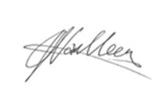 12 September 2025
Jazmin van Veen
Director, Local Planning (North, East and Central Coast)

Assessment officer
James Bellamy
Student Para Planner, Local Planning (North, East and Central Coast)
8275 1847

